Q1.
B: public class BankAccount {
private double balance;
public void deposit(double amount) {
if (amount > 0) balance += amount;
}
public void withdraw(double amount) {
if (amount > 0 && amount <= balance) balance -= amount;
}
}
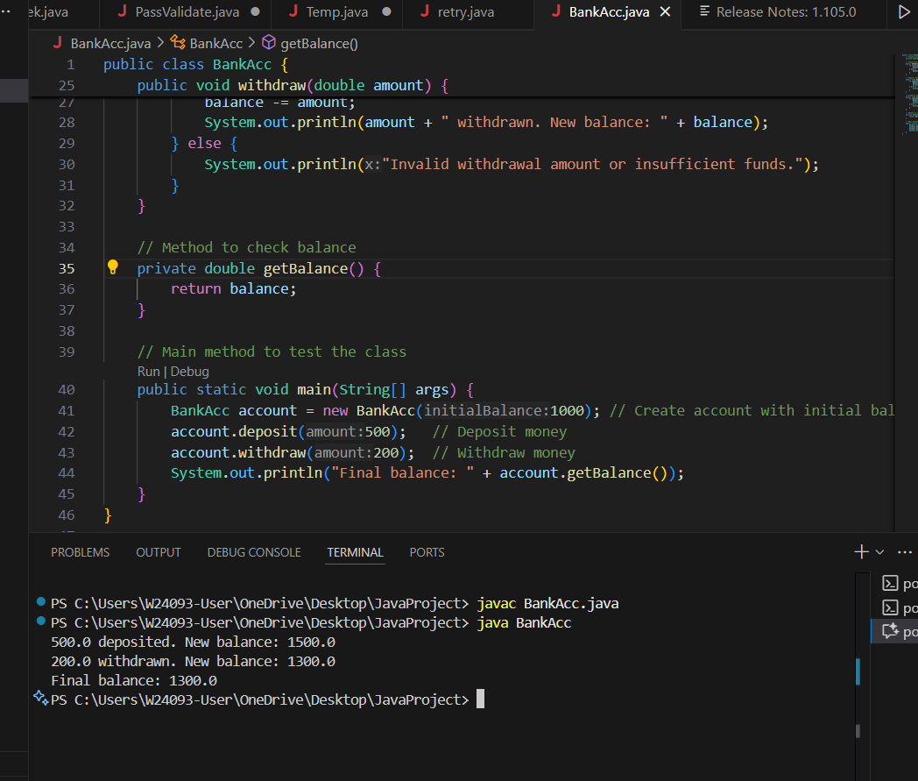
A: balance is public → anyone can change it → bad encapsulation.

B: balance is private and methods check input → good OOP

C: balance is static → shared by all accounts → wrong for individual accounts.

D: setBalance allows any value → can break rules → not safe for banking.

Q2.
B: public Employee(String name) { }

constructor is a special method used to initialize an object when it is created.
Name: Must be the same as the class name.
Return type: Cannot have a return type (not void, int, etc.).
It is different from normal methods.

A:Has void → This is not a constructor, it becomes a normal method.Incorrect.

B: Correct and best option

C: Valid, but not as flexible as public

D: Has void → Not a constructor. Incorrect

Q3.
B. public double calculateTotalPrice(Order order, double taxRate)

A: void → does not return total price

B:public: accessible from anywhere (good).
double return type: returns the total price (what we need).

C: private → cannot access from outside

D: returns Order → should return total price, not object

Q4.
B. public class InputValidator {
public static boolean validateEmail(String email) { /* validation logic */ }
public static boolean validatePhoneNumber(String phone) { /* validation logic */ }
}

· A utility class is meant to hold common reusable functions that can be used across multiple classes.
It doesn’t require object creation or inheritance.
· In a team project, using static methods improves code reusability, memory efficiency, and ease of access.

A: That’s unnecessary for a utility class — less efficient.

B: The methods are static, meaning they can be called without creating an object.

C: Abstract classes are meant for inheritance and overriding methods,
not for providing ready-to-use reusable logic.

D: Interfaces only define method signatures, not implementations.
Utility classes need actual working logic, so this isn’t suitable.

Q5.
- public abstract double calculateArea();

A: Gives a default value (0). Subclasses are not forced to override it

B: Abstract; subclasses must override

C: final means cannot be overridden,

D: Private; can’t access or override

Q6.
for (int i = 0; i < array.length; i++) { ... }

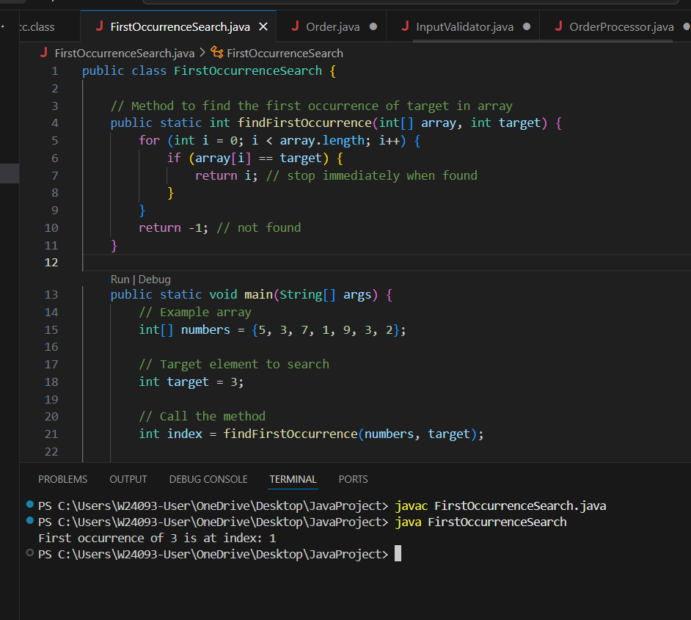
A: The index-based for loop gives direct access to both the element and its index.
You can return early (stop the loop) once the target is found — no need to check the rest of the array.
It’s clear, simple, and efficient for searching tasks.

B: Works but less clean

C: Risky for empty array

D: cannot get index easily.

Q7.
Answer A;
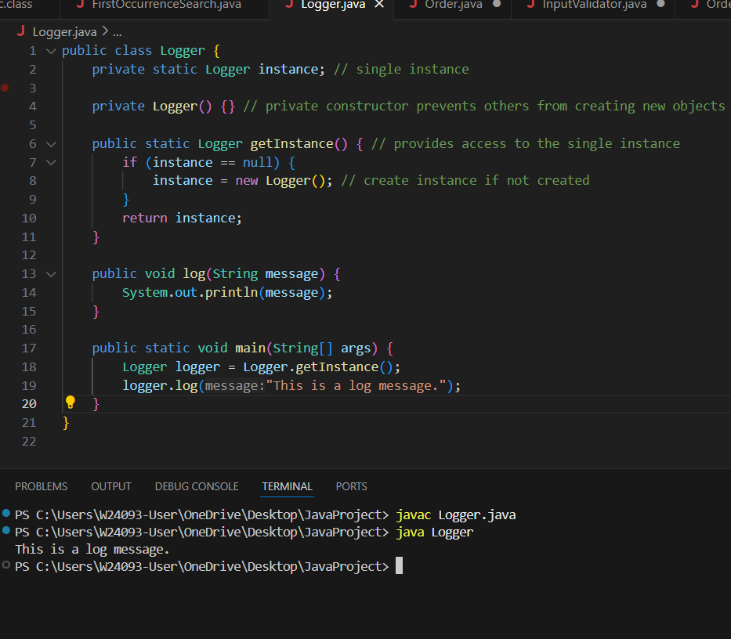
must use Singleton Design Pattern.

A: Private static variable stores the single instance.
Private constructor prevents creating objects from outside the class.
Public static method (getInstance) returns the single instance, creating it if necessary.
Single point of access ensures only one logger exists.

Q8.
Answer B;

public class Order {
private enum Status { NEW, PROCESSING, SHIPPED, DELIVERED }
private Status status;
public void setStatus(Status newStatus) {
status = newStatus;
}
}

A : String allows any value, no control.

B: is best — uses enum, so only valid statuses (NEW, PROCESSING, SHIPPED, DELIVERED) can be set.

C : int constants work but any int can be set, not readable.

D : String with checks works but easy to mistype and hard to maintain.

